# CS 494/594 Homework 4 (Fall 2022)

Instructor: Dr. Nirupama Bulusu

Due Date: **3/1/2022**

Name: Vishrut Sharma

For 594 students only: Review the following paper.

* Brandon Schlinker, Hyojeong Kim, Timothy Cui, Ethan Katz-Bassett, Harsha V. Madhyastha, Italo Cunha, James Quinn, Saif Hasan, Petr Lapukhov, and Hongyi Zeng. 2017. Engineering Egress with Edge Fabric. ACM SIGCOMM 2017.

https://research.facebook.com/publications/engineering-egress-with-edge-fabric/

1. **(25 points)** Consider the network shown below.

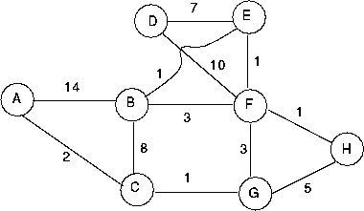

1. **(10 points**) Suppose that each node is running Dijkstra’s link state routing algorithm. Starting from an empty tree, determine the order in which the nodes are placed in G’s shortest path tree. Break ties using the alphabetical order (eg. B before C).

|  |  |  |  |  |  |  |  |  |  |
| --- | --- | --- | --- | --- | --- | --- | --- | --- | --- |
| *Iteration* | *Tree* | *A* | *B* | *C* | *D* | *E* | *F* | *G* | *H* |
| *Initial* | G |  |  | *1* |  |  | *3* | *-* | *5* |
| *1* | *G, C* | *3* | *9* | *-* |  |  | *3* | *-* | *5* |
| *2* | *G, C, A* | *-* | *9* | *-* |  |  | *3* | *-* | *5* |
| *3* | *G, C, A, F* | *-* | *6* | *-* | *13* | *4* | *-* | *-* | *4* |
| *4* | *G, C, A, F, E* | *-* | *5* | *-* | *11* | *-* | *-* | *-* | *4* |
| *5* | *G, C, A, F, E, H* | *-* | *5* | *-* | *11* | *-* | *-* | *-* | *-* |
| *6* | *G, C, A, F, E, H, B* | *-* | *-* | *-* | *11* | *-* | *-* | *-* | *-* |
| *7* | *G, C, A, F, E, H, B, D* | *-* | *-* | *-* | *-* | *-* | *-* | *-* | *-* |

*The nodes placed in node G's shortest path tree are GCAFEHBD*

1. **(15 points)** Now suppose that each node is running the distributed Distance Vector (DV) routing algorithm. Show how D's distance vector entries get updated from the initial step to step 1, and so on, until final convergence? (You can write your own software to compute the DV).

*D’s distance vector*

|  |  |  |  |  |  |  |  |  |
| --- | --- | --- | --- | --- | --- | --- | --- | --- |
|  | A | B | C | D | E | F | G | H |
| Initial |  |  |  | 0 | 7 | 10 |  |  |
| Step 1 |  | 8 |  | 0 | 7 | 8 | 13 | 11 |
| Step 2 | 22 | 8 | 14 | 0 | 7 | 8 | 11 | 9 |
| Step 3 | 16 | 8 | 12 | 0 | 7 | 8 | 11 | 9 |
| Step 4 | 14 | 8 | 12 | 0 | 7 | 8 | 11 | 9 |
| Step 5 | 14 | 8 | 12 | 0 | 7 | 8 | 11 | 9 |

2. **(35 points)** Across networking academic research and industry, Software defined networking (SDN) and network function virtualization (NFV) have been transformational. Long-time incumbents such as Intel, Broadcom, Cisco, and IBM have SDN products. Several startups such as Nicira, Contrail have been acquired. SDN solutions have been extensively deployed across enterprises and Google’s Wide Area Networks. Finally, SDN is anticipated to transform global-scale carrier networks (such as operated by AT&T, NTT, France Telecom, Deutsche Telekom, and others). To answer this question, you will need to perform some web-based research of your own!

a) **(20 points)** Explain how SDN requirements for carrier networks differ from datacenter networks.

**Answer**:

SDN is designed to offer users a way to manage network services through software that makes networks centrally programmable, which allows for faster configuration. Essentially, SDN makes the network programmable by separating the system that decides where traffic is sent (the control plane) from the underlying system that pushes packets of data to specific destinations (the data plane). And, SDN is built on switches that can be programmed through an SDN controller utilizing an industry-standard controller like OpenFlow.

SDNs can be used in a variety of domains but the requirements differ depending on which domain the SDN is being used in.

SDN requirements for carrier networks

Carrier networks want to decrease the operating cost and capital costs in their systems. But, they cannot implement SDN with the same factor as data, centers, because this domain creates new factors to focus on. First, the requirements for the carriers are end-to-end managed services, compliance with service level agreements, inter-carrier and vendor operability, support, and coexistence with legacy networks.

Based on the given requirements, carrier SDN will have a customizable service-based interface, capability module registrations, embedded function modules, programming interface and Network OS Kernel, and NE plane. It has to be multi-operator and multi-platform. In such a platform, customers will be able to enforce policy with an SDN controller whereas for the Data center SDN network the whole structure will be managed by the Network admin or engineers.

Furthermore, Network Function Virtualization is introduced to resolve some of the challenges in SDN. The primary vision is similar to NFV. The solution for carriers can be utilized in multiple domains. In conclusion, due to different requirements, the policies and architecture differ from the data center networks.

SDN requirements for Data center networks

In data centers, SDN provides functional separations, network virtualization, and automation through programmability. And, a sole focus on control planes with data planes and automation provides better help using programming functionality. An example of this would be, Google utilizing its data centers cooling optimally, utilizing a collection of data from SDN and providing it to the AI. The AI then came up with a better automation plan as per the usage. This was solely possible because of the SDN implementation.

b) **(15 points)** Give one example of a commercial SDN switch that can be deployed in data centers. What functions does it support to manage data center workloads?

An example of a commercial SDN switch that can be deployed in data centers is VMware NSX. VMware NSX Data Center virtualizes all networking and security functions to enable faster deployment through automation by reducing manual, error-prone tasks. Complete lifecycle automation of applications ensures that policy is provisioned, managed, and retired in lock step with workloads, eliminating operational bottlenecks in the application lifecycle. This automated process allows for fast, consistent networking and security across both traditional and new applications, regardless of where they reside in the data center, and with NSX Cloud, regardless of their location in public clouds. Automating traditional IT tasks, new cloud-native architectures, and platforms, and ongoing operations empower IT organizations and developers to move at the increasing speed of business

**3. (20 points)** Multicast Routing

Consider the topology shown below, and suppose that each link has unit cost. Suppose node H is chosen as the center (i.e., rendezvous point) in a center-based routing tree. Assume that each attached router uses its least-cost path to node H to send join messages to H. We also assume that nodes are joining in an alphabetic order (i.e., first A joins, then B etc.) Draw the resulting spanning tree in the figure. Is it unique? Justify your answer.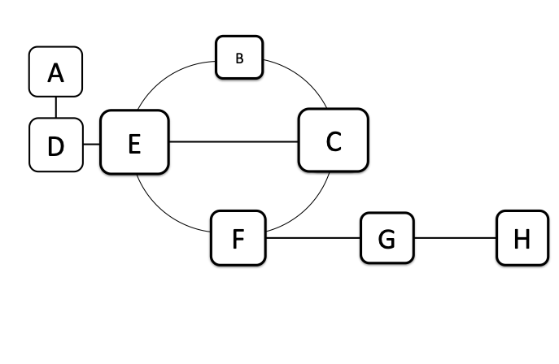

**Answer :**

The spanning tree is not unique.

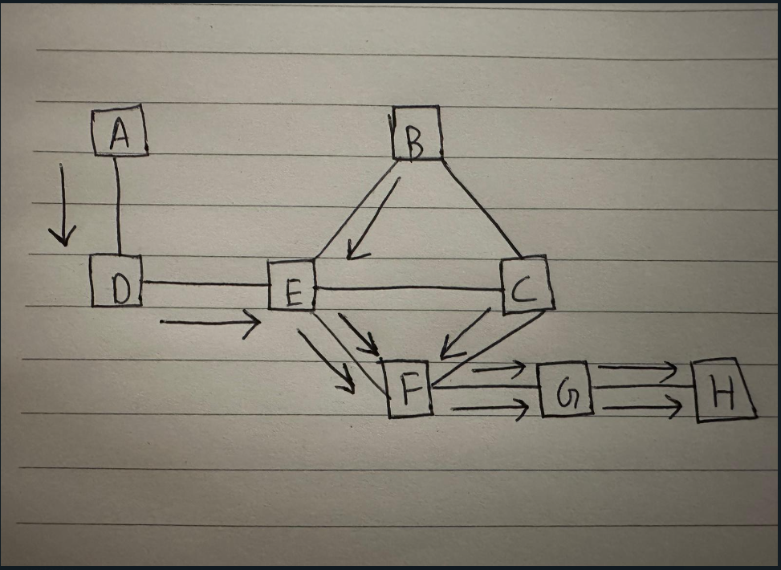

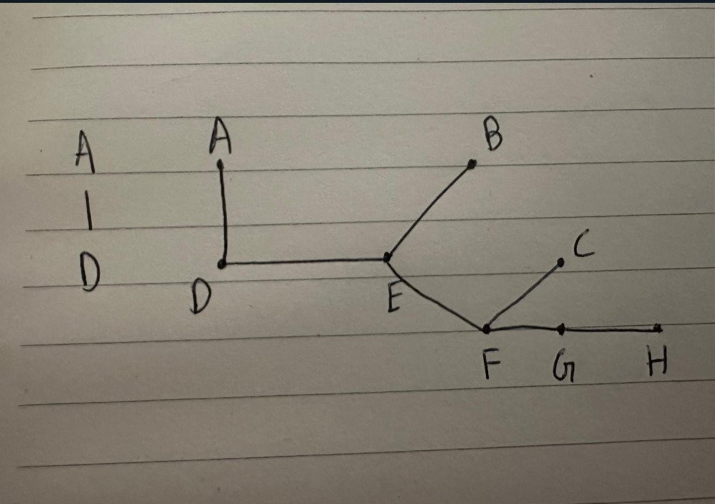

(4. **(15 points) BGP**

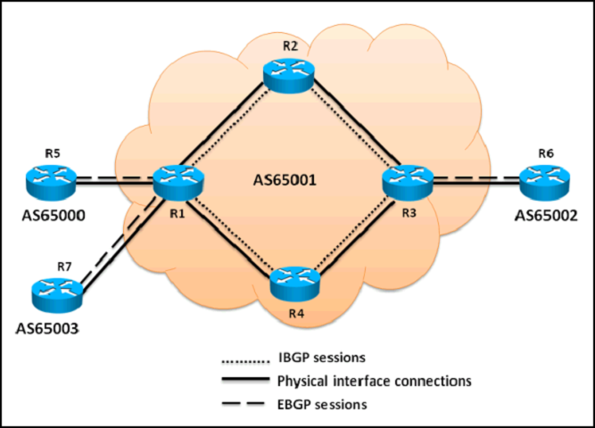

Consider the topology diagram above (source : Cisco).

Which of the following three statements are correct regarding the BGP routing updates? (Choose three.)

1. The EBGP routing updates received by R1 from R5 will be propagated to the R2, R4, and R7 routers
2. The EBGP routing updates received by R3 from R6 will be propagated to the R2 and R4 routers
3. The EBGP routing updates received by R1 from R5 will be propagated to the R2 and R4 routers
4. The IBGP routing updates received by R3 from R2 will be propagated to the R6 router
5. The IBGP routing updates received by R2 from R1 will be propagated to the R3 router
6. The IBGP routing updates received by R1 from R4 will be propagated to the R5, R7, and R2 routers

**Answer:**

Option A, B, and D